use assignment3;

-- task 1

select `FIRST_NAME`, `LAST_NAME` from employees where `SALARY` > (

    select `SALARY` from employees where `LAST_NAME` = 'Bull'

);

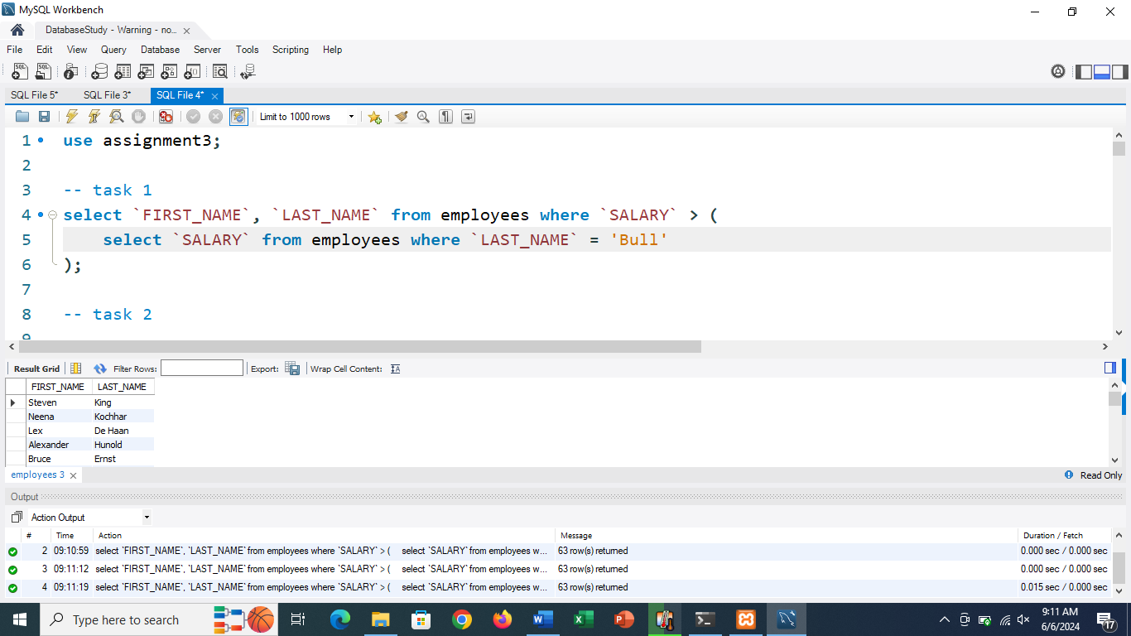

-- task 2

select `FIRST_NAME`, `LAST_NAME` from employees where `DEPARTMENT_ID` = (

    select `DEPARTMENT_ID` from department where `DEPARTMENT_NAME` = 'IT'

);

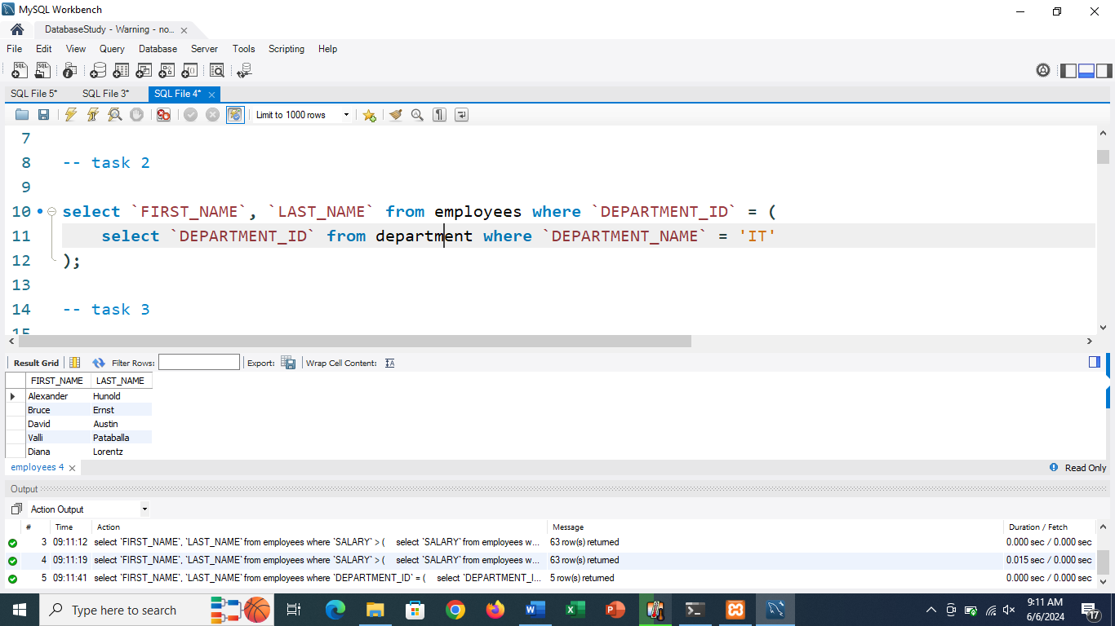

-- task 3

select `FIRST_NAME`, `LAST_NAME` from employees where `DEPARTMENT_ID` IN (

    select `DEPARTMENT_ID` from department where `DEPARTMENT_ID` in (

        select `DEPARTMENT_ID` from location where country_id = 'US'

    )

) and `EMPLOYEE_ID` in (

    select `EMPLOYEE_ID` from employees where `MANAGER_ID` is not null

);

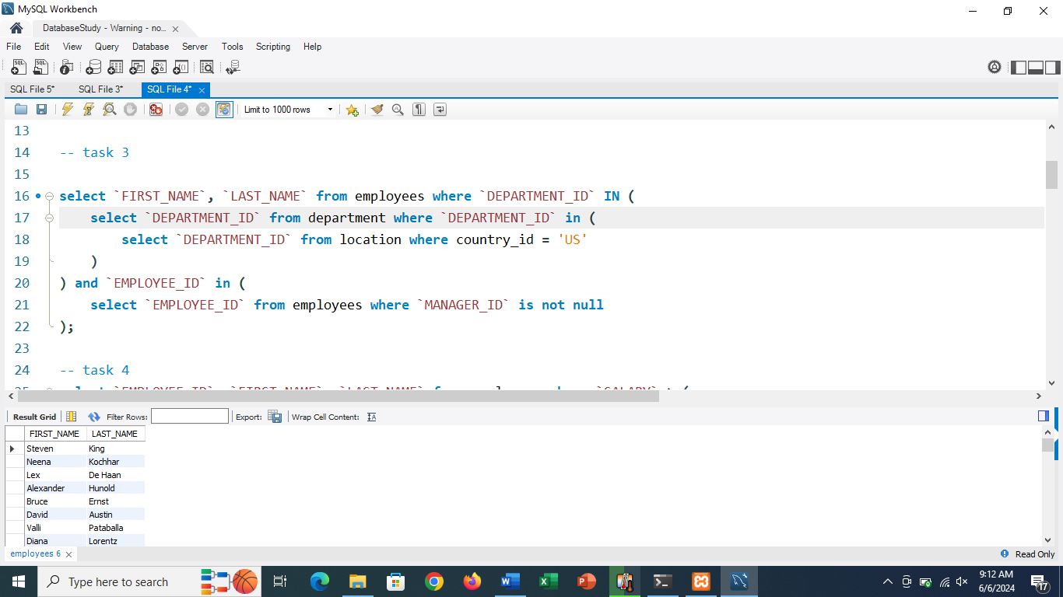

-- task 4

select `EMPLOYEE_ID`, `FIRST_NAME`, `LAST_NAME` from employees where `SALARY` > (

    select AVG(`SALARY`) from employees

);

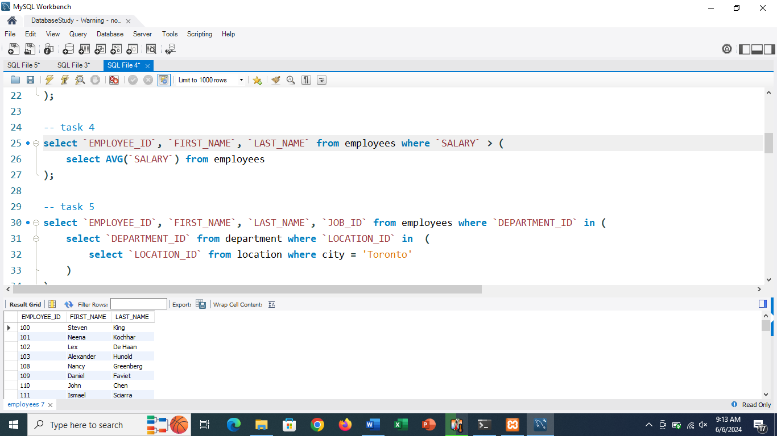

-- task 5

select `EMPLOYEE_ID`, `FIRST_NAME`, `LAST_NAME`, `JOB_ID` from employees where `DEPARTMENT_ID` in (

    select `DEPARTMENT_ID` from department where `LOCATION_ID` in  (

        select `LOCATION_ID` from location where city = 'Toronto'

    )

);

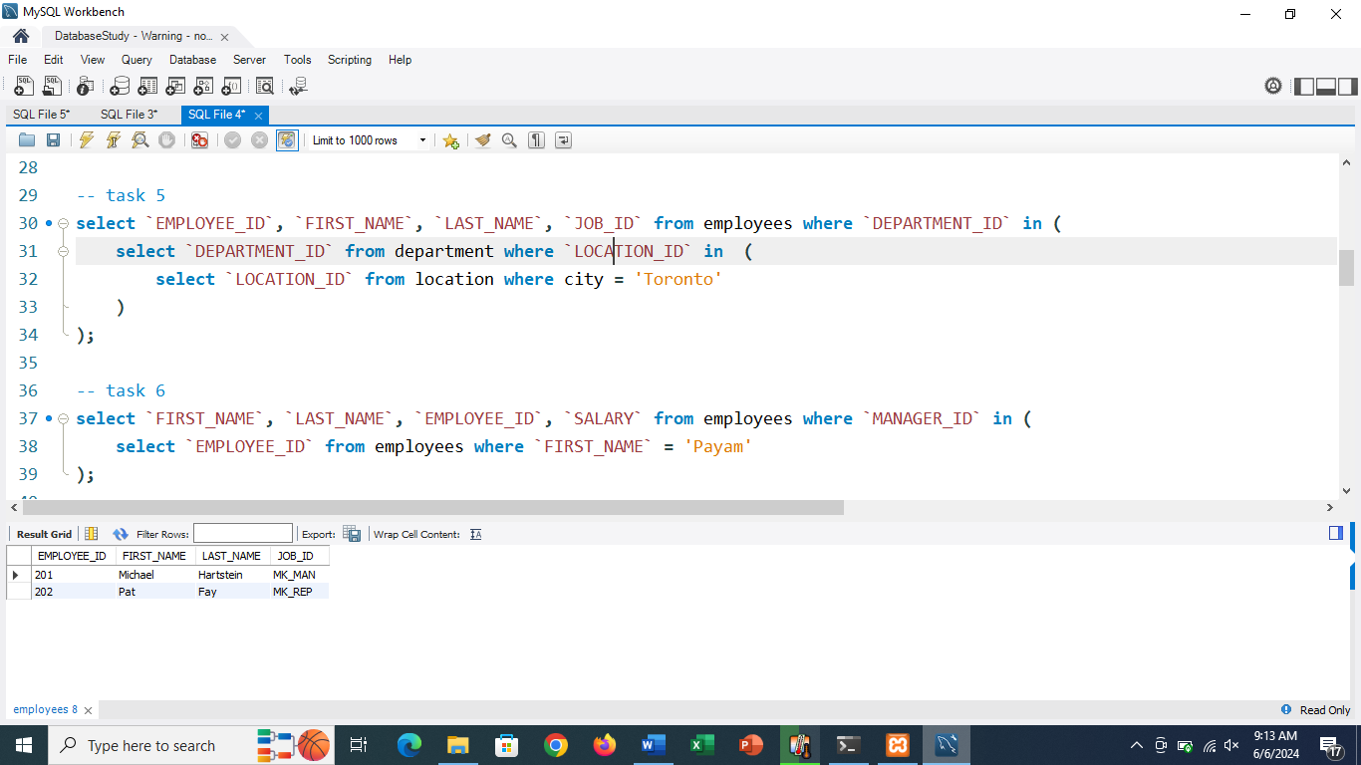

-- task 6

select `FIRST_NAME`, `LAST_NAME`, `EMPLOYEE_ID`, `SALARY` from employees where `MANAGER_ID` in (

    select `EMPLOYEE_ID` from employees where `FIRST_NAME` = 'Payam'

);

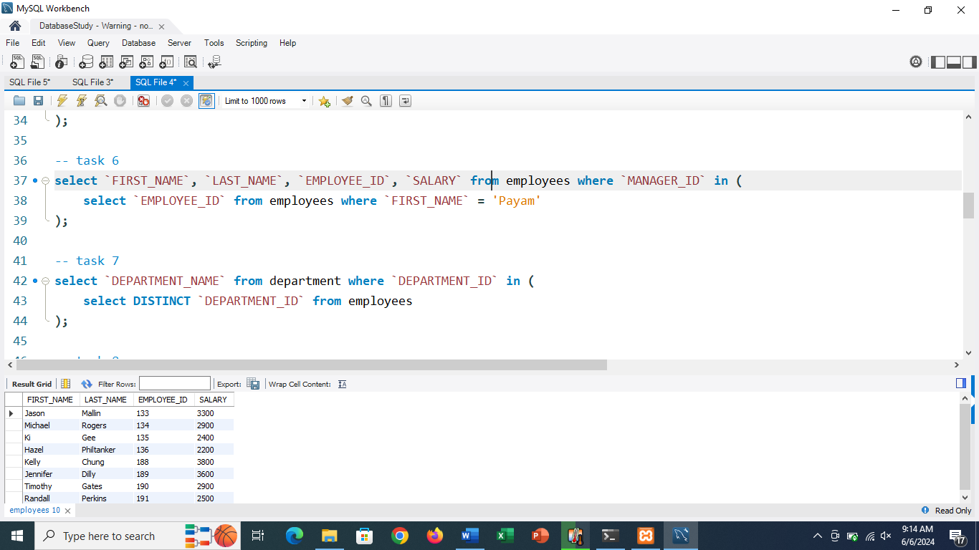

-- task 7

select `DEPARTMENT_NAME` from department where `DEPARTMENT_ID` in (

    select DISTINCT `DEPARTMENT_ID` from employees

);

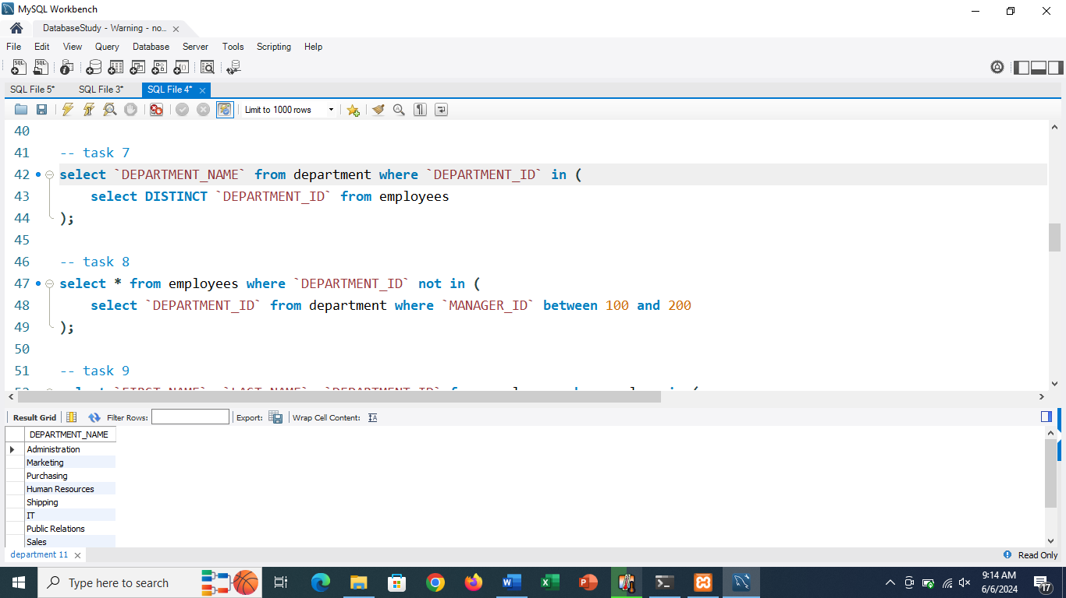

-- task 8

select * from employees where `DEPARTMENT_ID` not in (

    select `DEPARTMENT_ID` from department where `MANAGER_ID` between 100 and 200

);

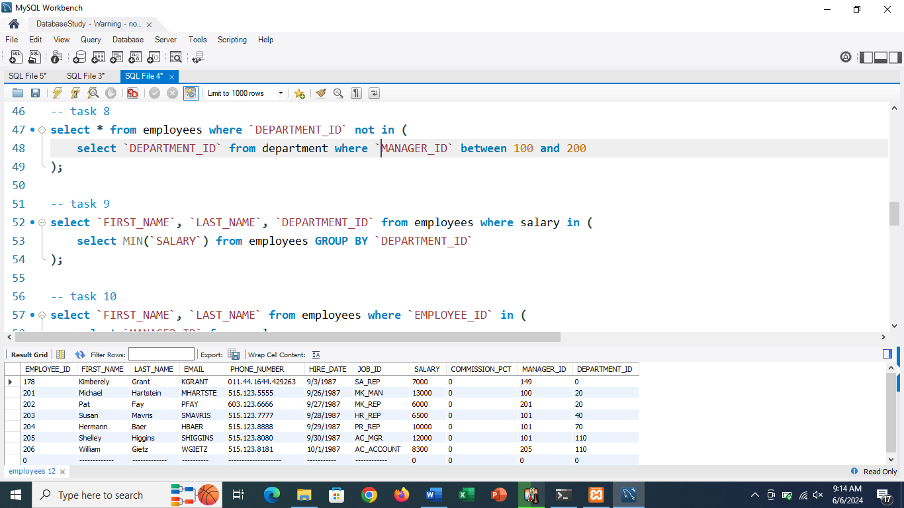

-- task 9

select `FIRST_NAME`, `LAST_NAME`, `DEPARTMENT_ID` from employees where salary in (

    select MIN(`SALARY`) from employees GROUP BY `DEPARTMENT_ID`

);

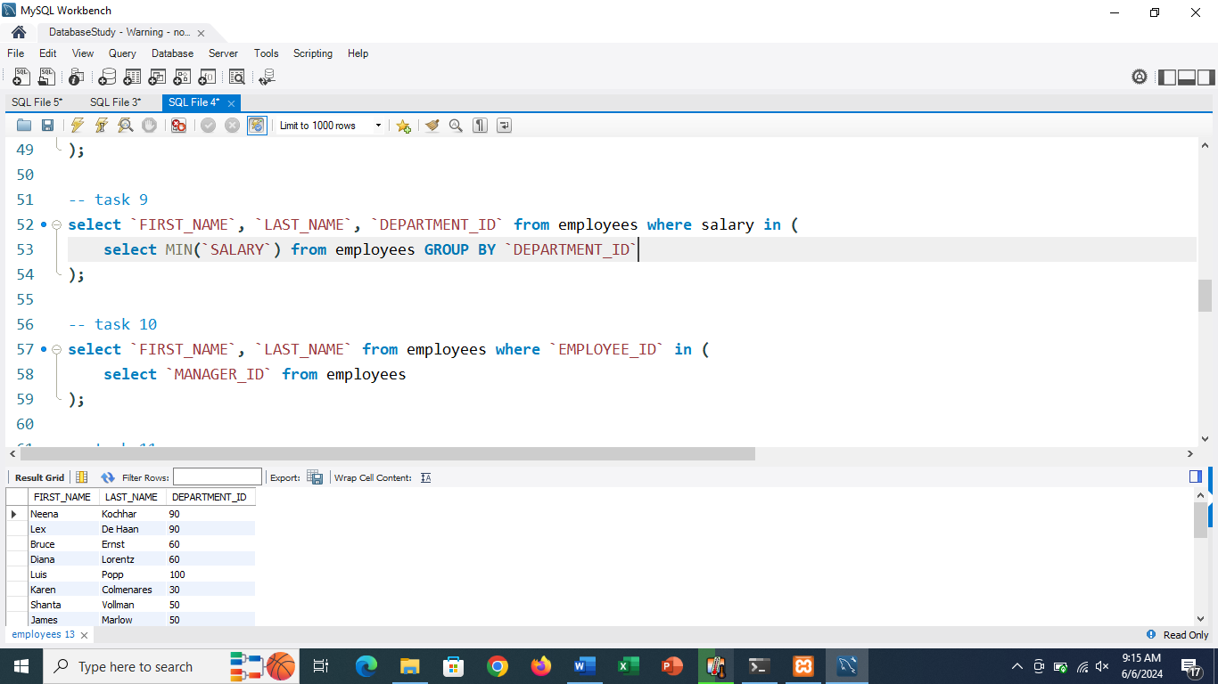

-- task 10

select `FIRST_NAME`, `LAST_NAME` from employees where `EMPLOYEE_ID` in (

    select `MANAGER_ID` from employees

);

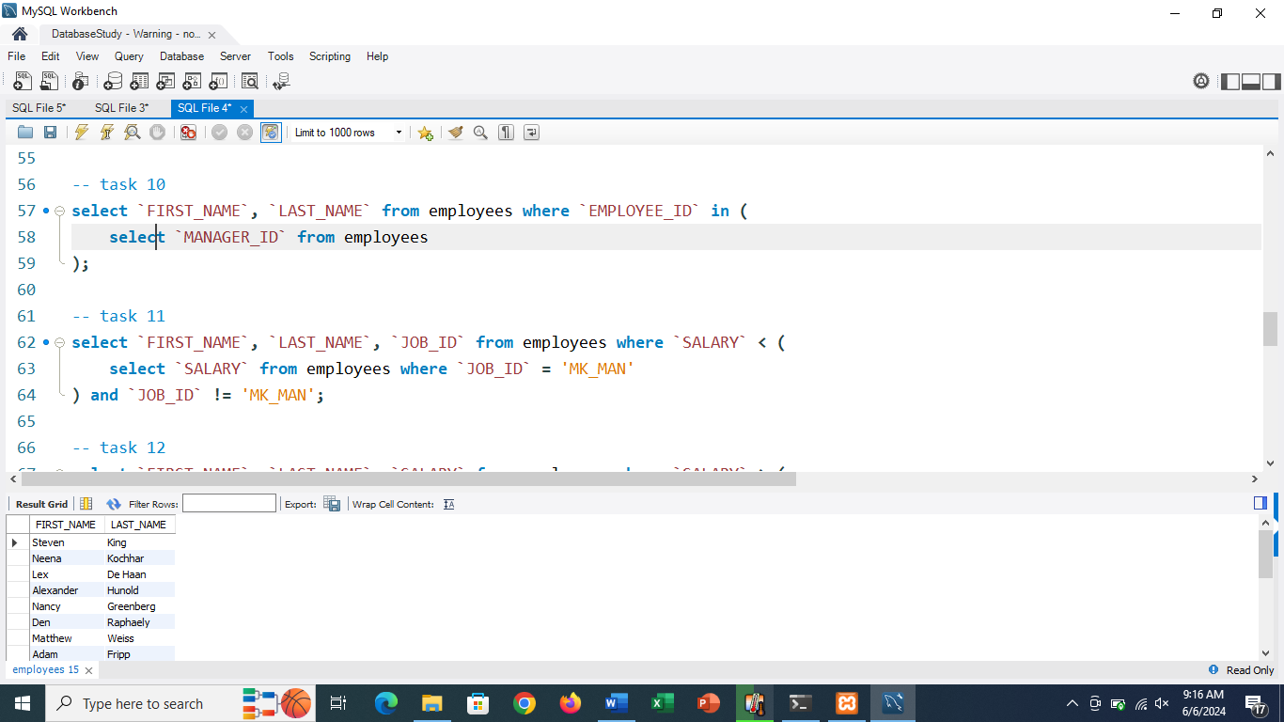

-- task 11

select `FIRST_NAME`, `LAST_NAME`, `JOB_ID` from employees where `SALARY` < (

    select `SALARY` from employees where `JOB_ID` = 'MK_MAN'

) and `JOB_ID` != 'MK_MAN';

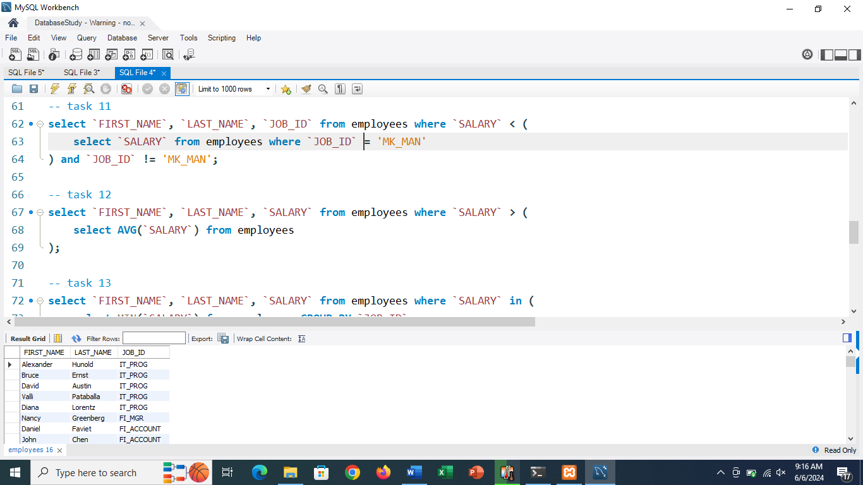

-- task 12

select `FIRST_NAME`, `LAST_NAME`, `SALARY` from employees where `SALARY` > (

    select AVG(`SALARY`) from employees

);

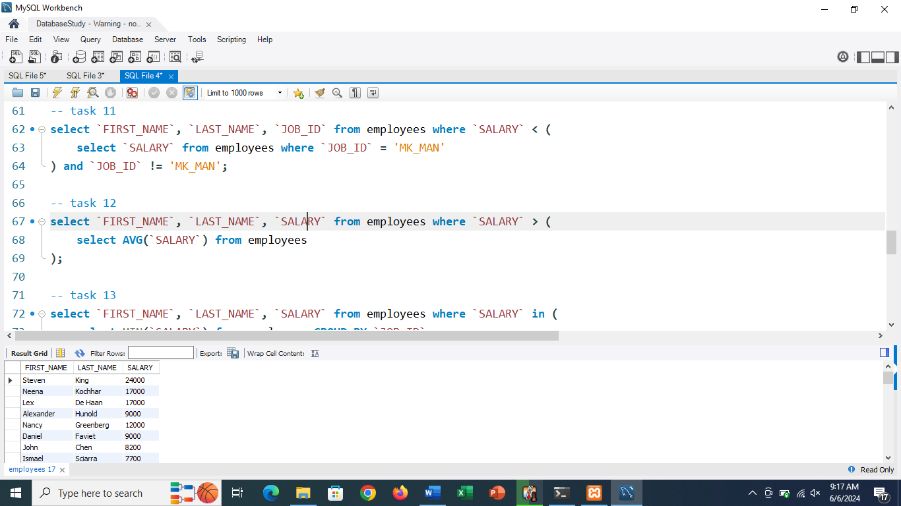

-- task 13

select `FIRST_NAME`, `LAST_NAME`, `SALARY` from employees where `SALARY` in (

    select MIN(`SALARY`) from employees GROUP BY `JOB_ID`

);

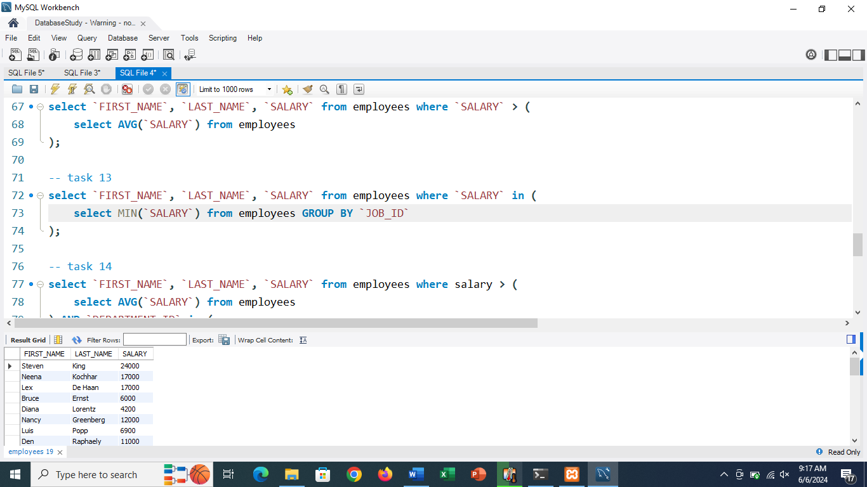

-- task 14

select `FIRST_NAME`, `LAST_NAME`, `SALARY` from employees where salary > (

    select AVG(`SALARY`) from employees

) AND `DEPARTMENT_ID` in (

    select `DEPARTMENT_ID` from department where `DEPARTMENT_NAME` like '%IT%'

);

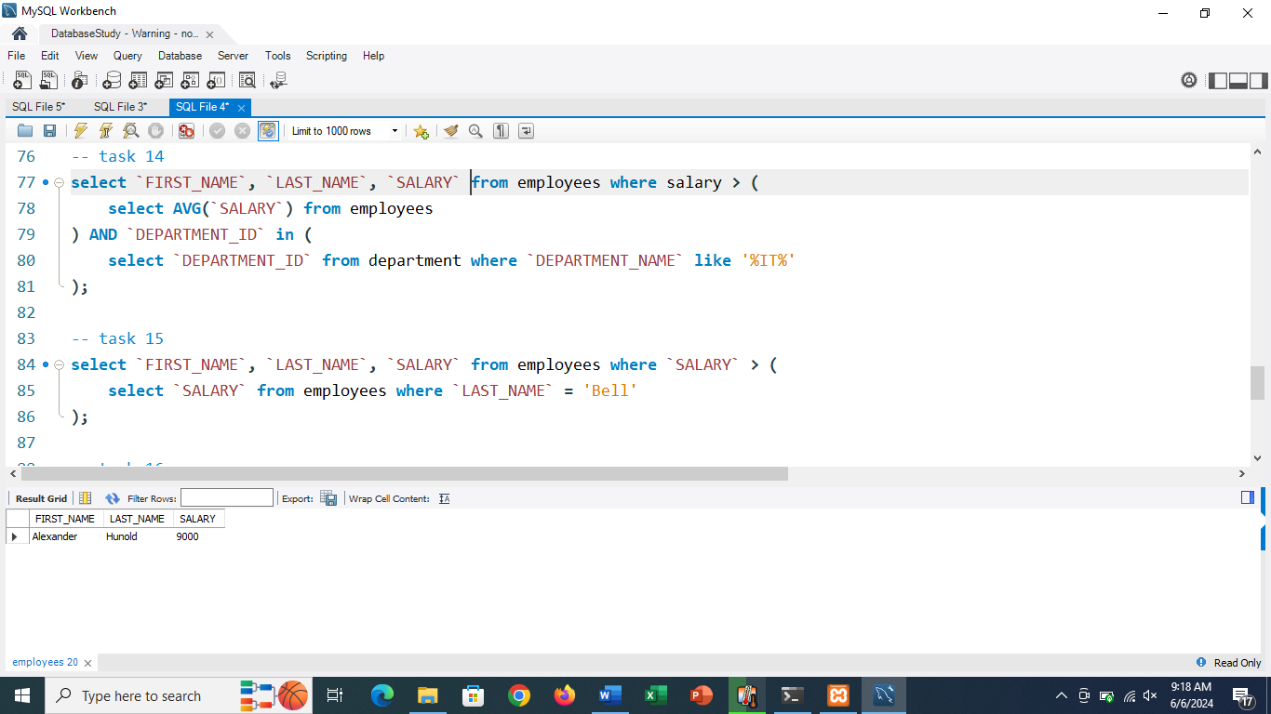

-- task 15

select `FIRST_NAME`, `LAST_NAME`, `SALARY` from employees where `SALARY` > (

    select `SALARY` from employees where `LAST_NAME` = 'Bell'

);

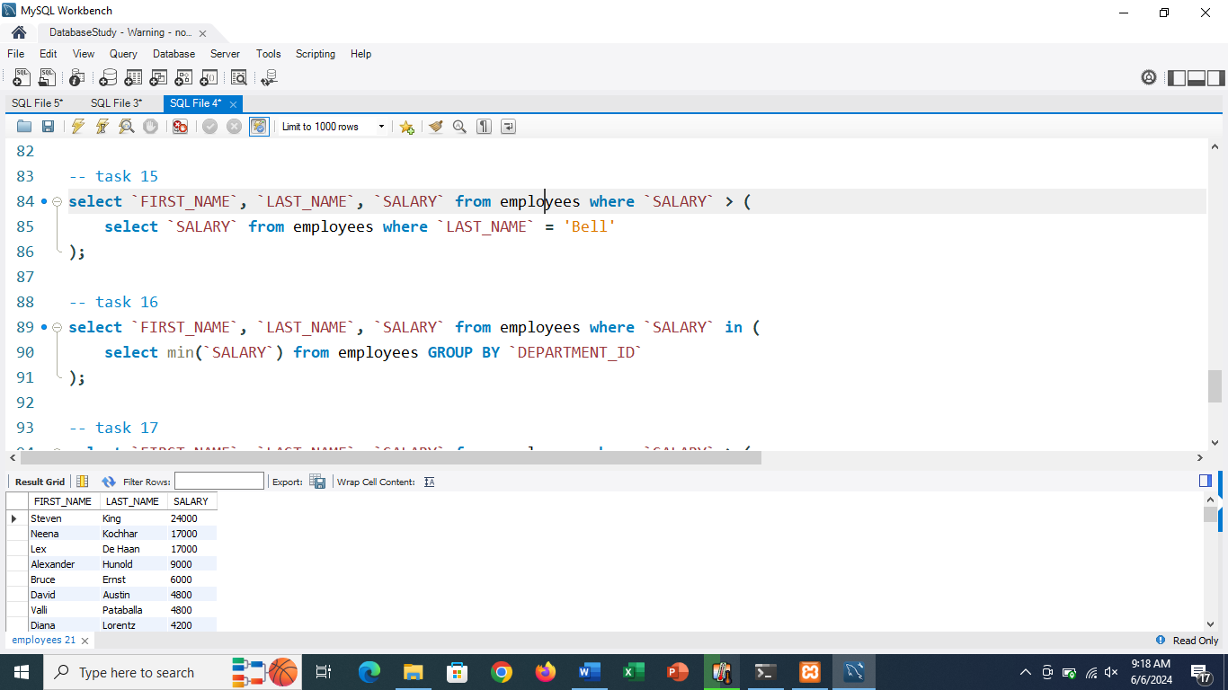

-- task 16

select `FIRST_NAME`, `LAST_NAME`, `SALARY` from employees where `SALARY` in (

    select min(`SALARY`) from employees GROUP BY `DEPARTMENT_ID`

);

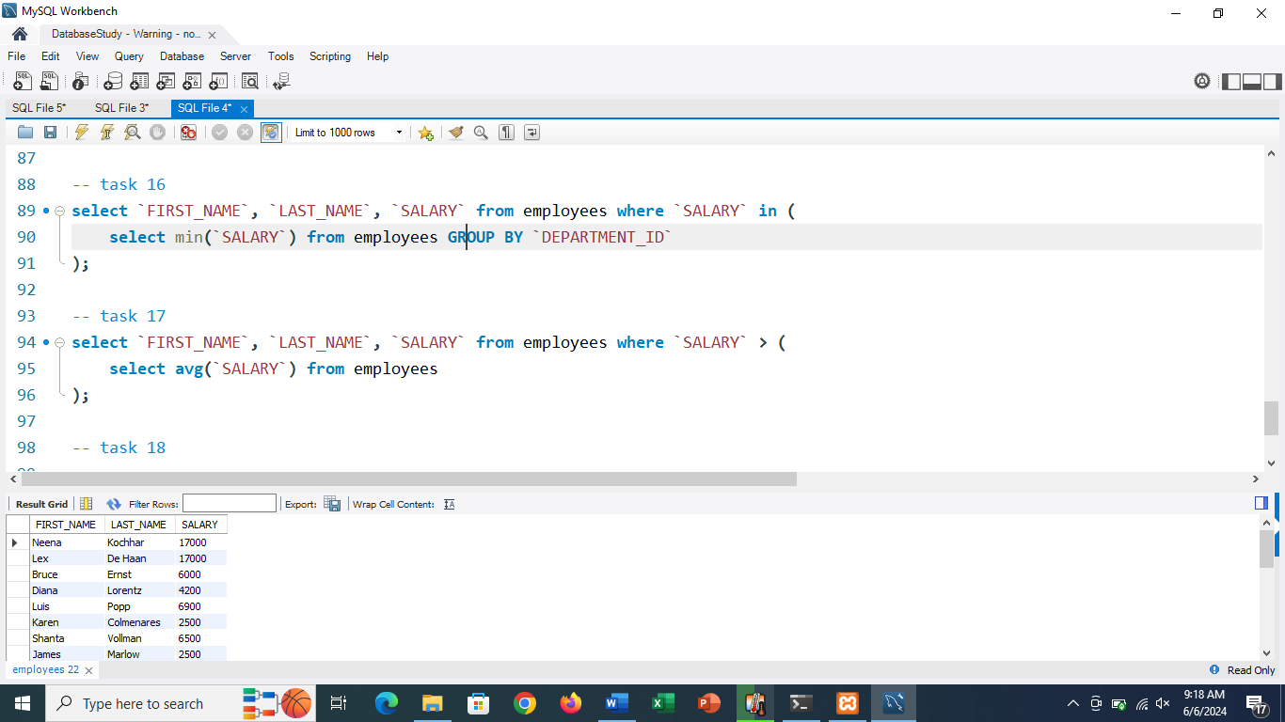

-- task 17

select `FIRST_NAME`, `LAST_NAME`, `SALARY` from employees where `SALARY` > (

    select avg(`SALARY`) from employees

);

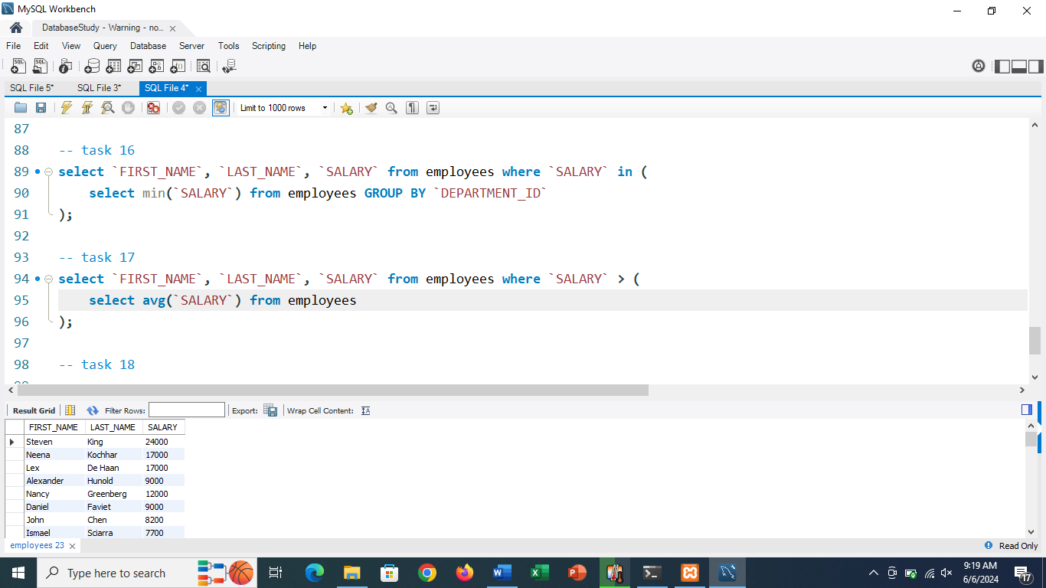

-- task 18

select `SALARY` from (

    select DISTINCT `SALARY` from `employees` ORDER BY `SALARY` DESC LIMIT 3

) AS top_salaries ORDER BY `SALARY` LIMIT 1;

